
Christmas Gift Help Available!
Sign ups start soon! Don’t miss
this opportunity this year!

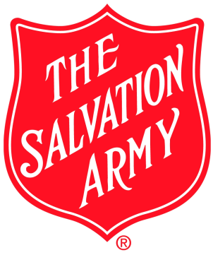
Salvation Army Christmas Assistance Sign Ups
The Salvation Army Christmas Assistance Sign Ups for children in the Brookville area will be held this year on October 23 and October 30. This program provides age appropriate gifts for children ages 0 – 13. This year’s Sign Ups will be held at the Brookville Area Food Pantry Building on Allegheny Boulevard from 10-Noon and 6:30-7:30 both days during regular food pantry hours. Items required to meet eligibility are: photo ID, proof of age for each child, proof of income or benefits and proof of address within the Brookville area.


Gifts For Angels Christmas Assistance Sign Ups
In addition, the Gifts for Angel’s program provides items for children through ages 18 or older if still in high school. Items include clothing, hobby, footwear and toys for eligible children. The Sign Ups for this year’s program will be held October 23 and October 30 at the Brookville Area Food Pantry Building on Allegheny Boulevard from 10-Noon and 6:30 – 7:30 p.m. both days during regular food pantry hours. If you are a current patron of the Food Pantry, please bring the children’s ages, clothing sizes, hobby interests and shoe sizes. The date for the gift distribution of both programs will be Thursday, December 18, at the Brookville Food Pantry Building during regular operating hours. Participants may only apply for help with one organization.
Anyone wanting more information about these Christmas Assistance Programs can contact the Brookville Area Food Pantry at 814-849-0818 or Tawnia Norris at 814-648-0819.



